Name of Event – can go to two lines with correct spacing

Date of Event

“Theme or Title”

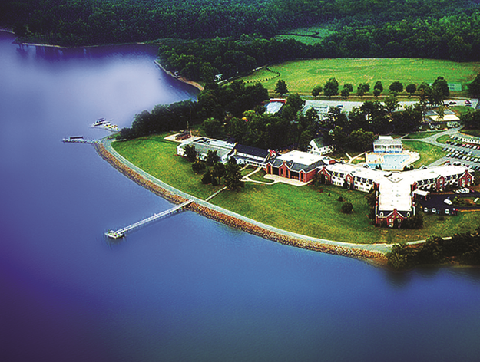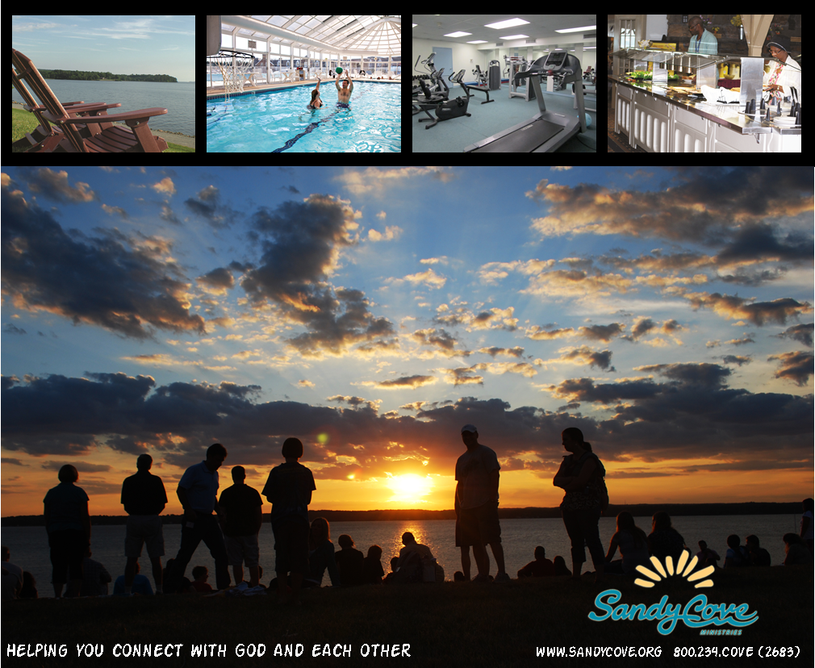

With [Special Guests – Speaker / Worship Leader]

To register [sign up at table in church foyer]

To get more information [call, email, website]

Cost

What to bring [Bible, notebook, modest one-piece swimsuit]