Name of Event

[Date of Event]

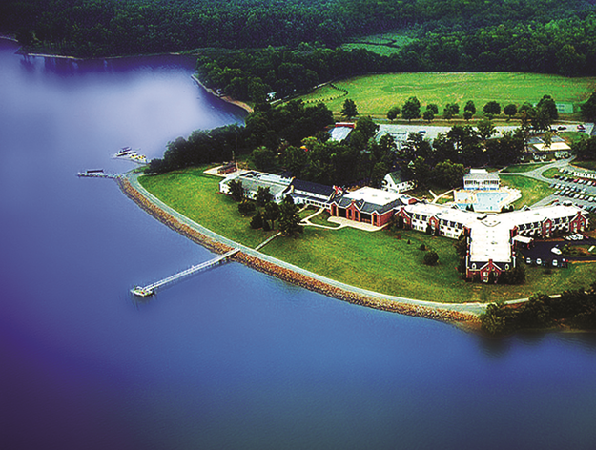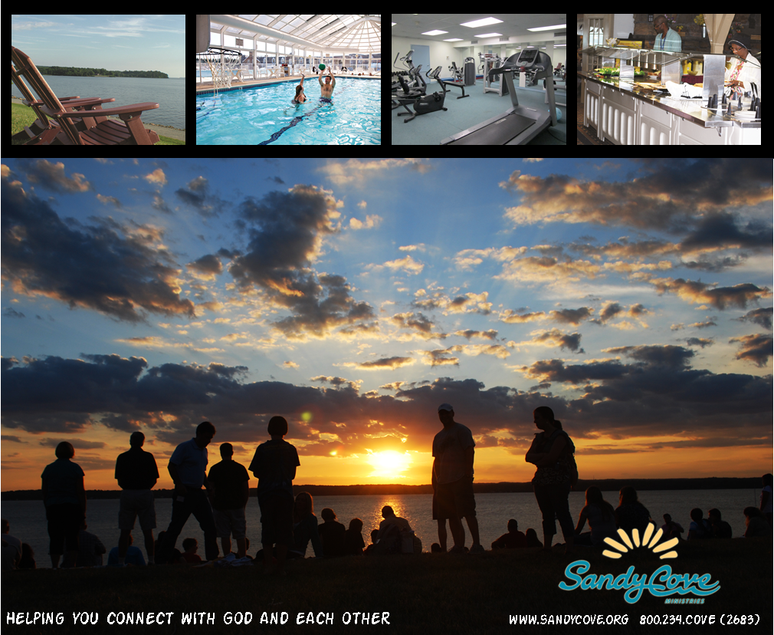

[Theme of Event “Living for Jesus!”]

With [Special Guests – Speaker / Worship Leader]

To register [sign up at table in church foyer]

To get more information [call, email, website]

Cost

What to bring [Bible, notebook, modest one-piece swimsuit]